* 1. ROM is read only memory and it’s primary purpose is allowing a computer to start up or regenerate each time it is turned on.
  2. RAM is random access memory, RAM is volatile memory that temporarily stores the files you are working on, while ROM permanently stores instructions for your computer
  3. SRAM retains data bits in its memory as long as power is being supplied, while DRAM must continuously refreshed.
  4. USB typically uses solid state flash memory, first, it has a limited number of write cycles, and it can also be susceptible to data loss if it is exposed to strong magnetic fields, extreme temperatures, or physical damage.

2. 2^30 which is 30 bits

3. The Von Neumann architecture is a type of computer architecture where the program instructions and data are stored in the same memory and share the same bus. While on the other hand, the Harvard architecture is a type of computer architecture where the program instructions and fata are stored is separate memories and have separate buses.

The fundamental difference between the two is the way they handle data and instructions.

4. Cache memory is a type of high-speed memory that is used to temporarily store frequently accessed data and instructions. The primary role of cache memory is to improve the performance of a computer system by reducing the time it takes for the CPU to access frequently used data and instructions.

5. An interrupt is a signal sent to the CPU by a device or program that requires the CPU's immediate attention.

- Timer Interrupt = generated by a timer device

- Hardware interrupt = generated by an external device

- Software interrupt = generated by software program

- Exception interrupt = generated by the CPU

5.1 Polling is an alternative to interrupts for managing external events or requests in a computer system. It can be time-consuming and inefficient to poll a device or programme, which entails repeatedly verifying its status. As a result, it is not commonly used in modern computer systems.

6. A stack is a type of data structure that is used to store and manage data in a LIFO manner. This means that the last element added to the stack is the first one to be removed. The primary purpose of a stack is to give a simple and efficient way to manage data in Last-In-First-out (LIFO) manner, making it a helpful tool to manage function calls and program execution.

6.1 Because they allow the CPU to quickly and efficiently switch between executing the current program and handling an interrupt.

6.2 It provides a simple and efficient way to manage function calls and program execution. When a function is called, its local variables and the return address are pushed onto the stack. The function then executes, and when it completes, its local variables and the return address are popped from the stack.

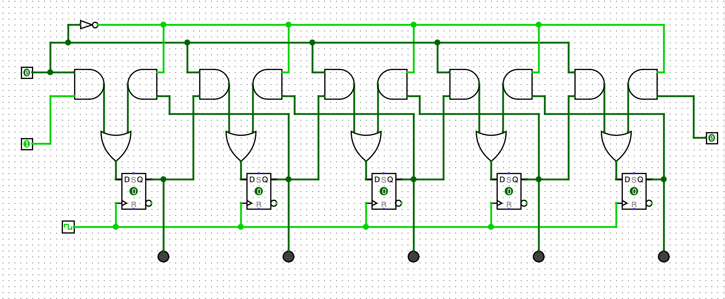**5-BIT DEEP STACK**